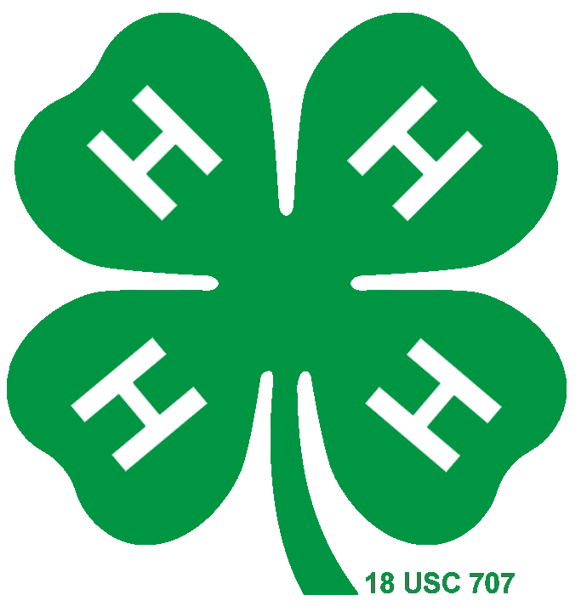
Insert your Photo here

Dunn County
4-H MEMBER
Yearly Plan and Record Book

Name:
Club Name:
4-H Participation
Year | Age | Grade | Years in 4-H  Cloverbuds + this year | Club Meetings
 |  |  |  | # Held | # I Attended
Age is as of October 1st (4-H Calendar Year) and grade is the last year completed.

Plaque disc you’re applying for:
County project award(s) you’re applying for:
4-H Project Summary
Use a separate sheet (summary and reflection) for each project heading your applying an award in for in this year.

Year: | Project: |  | Years in project:
Date(s): | Activity Summary: | Income |  | Expenses | Hours  worked
Project Totals
**Note: It is OK to show a loss

Supporting documentation

Please give us evidence of your project activities through scrapbook photos, awards, newspaper clippings, or any media format you wish. Please site where this information can be found if on any other Media format other then printed.

4-H Project Reflection & Goals

Project: __________________ Years in the project: ______________

Please explain your answers to the following questions in no more than 1-2 paragraphs for each:

1) What were your highlights and low-lights of this project?

2) How did you grow and share your skills in this area?

3) What could you do to improve in this area for next year and why?

4) What goals did you have this year for this project? What evidence can you give that shows improvement on these goals?

Project Listing By Year Table

Directions: Please place a check mark or an X in the corresponding box for each year you have taken the corresponding project

 | 2014 | 2015 | 2016 | 2017 | 2018 | 2019 | 2020 | 2021 | 2022 | 2023 | 2024 | 2025
Feel free to changes the dates to more accurately represent your time in a project area.

