DUNN COUNTY 4-H
JUNIOR
RECORD BOOK

To be completed by Explorers (or members in grades 3-5)

Note: Check with your club leader for specific record book requirements.

Name: __________________________________________ Year: ______________

Address: _________________________________________________________________

Birthdate: _____________________ Age: _________ Grade: _____________

Club Name: _________________________________ # Years in 4-H: ______

Junior Record Book Instructions

- Use this record book for all the things you do in 4-H this year.
- Use separate "Project Plan", "Project Diary", and "This is what I did in my 4-H project" forms for each of your projects.
- Use your record to look back at the progress you have made during the year. This will be helpful when you make plans for next year.
- When you complete your 4-H program for this year, write your 4-H story.
- You will want to keep only the most important materials in the memories part of your record. You may want to keep a scrap- book of ribbons, certificates, programs, and other materials.
- The record book is your personal work. It should be kept current as the year progresses. Handwriting or typing should be your own.
- You may want to organize your records with tabs in a binder.
  - A suggested order for doing this is:
    - Introduction
    - My 4-H Planning Calendar
    - Projects (separate tabs for each project)
    - Permanent Record
    - My 4-H Story
    - My 4-H Memories
    - Comment Page
- Obtain the required signatures.

4-H Planning Calendar and Participation Summary
Put an “X” after each event you attend.
O C T O B E R | Event Title or Description with Date | X

N O V E M B E R
D E C E M B E R

J A N U A R Y

F E B R U A R Y

M A R C H

A P R I L

M A Y

J U N E

J U L Y

A U G U S T

S E P T E M B E R

CLUB COMMITTEES OR LEADERSHIP ROLES
Year | Office or Committee

CLUB ACTIVITES AND ACHIEVEMENTS
Year | Activity or Achievement

COMMUNITY ACTIVITES AND ACHIEVEMENTS
Year | Activity or Achievement

PROJECT PLANS

My 4-H project is:

I chose this project because:

Some of the things I want to do or learn in my 4-H project this year are:

Member: _________________________________________
Parent/Guardian: ___________________________________
Leader:___________________________________________
PROJECT PLANS
Date | What did you do or maker? | How Many?  How Much? | Cost | Income / Value
Totals:
PROJECT REFLECTIONS
I learned these skills:

The highlight of my project was:

Why do you want to receive a disc in this project?

Pictures, Clippings, & Other Cool Stuff

MY 4-H STORY
Some things about myself and my family are. . .

I joined 4-H because. . .

Some of the things my club and project group did this year were. . .

MY 4-H STORY
My favorite parts of 4-H this year were . . .

Some things I would like to do better, improve upon, or do more of next year are . . .

MY 4-H MEMORIES
Paste pictures of you, your club, drawings, newspaper clippings, letters,
awards, or anything related to you and your club or 4-H project.

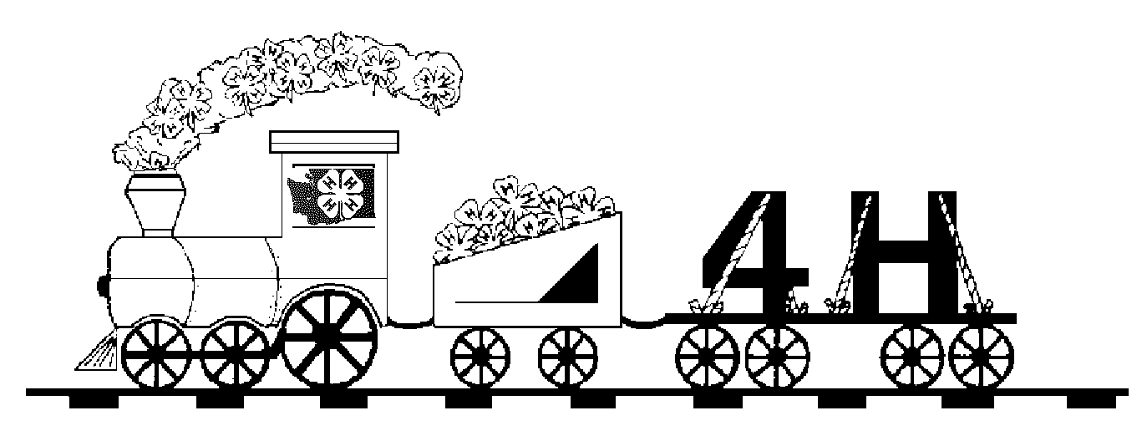
MY 4-H MEMORIES

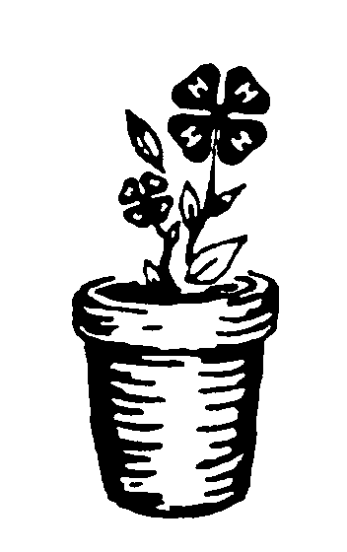
COMMENT PAGE
To be filled out by leaders, record book judges, and others at the end of the 4-H year.

______________________________________________________________________________________________________________________________________________________________________________________________________________________________________________________________________________________________________________________________________________________________________________________________________________________________________________________________________________________________________________________________________________________________________________________________________________________________________________________________________________________________________________________________________________________________________________________________________________________________________________________________________________________________________________________________________________________________________________________________________________________________________________________________________________________________________________________________________________________________________________________________________________________________________

I have reviewed this record book and believe it to be correct.
Member _____________________________________________ Date ________
Parent/Guardian _______________________________________ Date ________
Leader _______________________________________________ Date ________
Leader ______________________________________________ Date ________

