Dunn County 4-H Record Book Process

Each 4-H member in Dunn County is encouraged to complete a Record Book to showcase their project development throughout the year. The following documents and procedures are encouraged for everyone, but each club has the discretion to modify or change these guidelines for fulfillment of their record book requirements.

If a member intents to submit their records for County-wide awards consideration, please refer to the checklist at the end of this document, and available online at the Dunn County UW-Extension website under 4-H Forms and Documents.

Record Book Outline:
- Cover Letter
- Resume
- Submission of 1 of the approved Record Book Formats
  - These formats may include:
    - Traditional Book, PowerPoint, Prezi, or Similar Presentation, Website or webpage, Blog, V-cast or Podcast, Other, as approved by 4-H Agent
- Project Listing Chart

Approved Record Book Formats

- Traditional 4-H Record Book – A traditional 4-H Record Book using latest requirements and forms available. The latest and current version of the traditional book will be posted on the Dunn County UW-Extension website under 4-H Forms and Documents
- Submission must be in paper format with cover pages in a three ring binder or portfolio cover.
- Recommended for 4-H members in grades 4-5 who are completing a 4-H Record for the first time.

- PowerPoint, Prezi or Similar Presentation – A visual software or web application presentation of 4-H records and member’s learning and reflection.
- Presentations must include at least thirty (30) slides/views with font large enough to read.
- 4-H Project Records can be incorporated into the presentation for each project.
- Submission for PowerPoint presentations must be printed slides large enough to read without strain. Prezi or similar presentations can be submitted via flash drive or web link if printing is not feasible.
- Recommended for 4-H members grades 3- 12 who are interested in using technology to visually represent their 4-H year.

- Webpage or Website – A visual software or web application presentation of 4-H records and member’s learning and reflection.
- Should include a navigation bar to organize your webpage(s).
- 4-H Project Records can be incorporated into the webpage or website for each project. Submission shall be via print. If printing is not feasible, then a web link submission will be accepted.
- Recommended for 4-H members grades 9-12 who are interested in format.

- Blog – A blog (web+log) is online, public journal. 4-H member will use a blog to document their 4-H experiences throughout the year in a journal format.
- There should be at least twenty (20) blog posts and at least one (1) blog post in each month of the 4-H club year running from October – September.
- 4-H Project Records can be incorporated into the blog for each project. Submission shall be via print. If printing is not feasible, then a web link submission will be accepted.
- Recommended for 4-H members grades 3- 12 who are interested in using technology to document their 4-H experiences throughout the year in a journal format.

- V-cast or Podcast – A video or audio presentation with a typed script that discusses member’s learning and reflection.
- 4-H Project Records to be incorporated into the v-cast/podcast for each project.
- Files must be file formats ready to be played on Real Player software.
- Submission will be via flash drive, web link or other format appropriate and approved by 4-H Agent by September 1.
- Recommended for 4-H members in grades 9-12 who are interested in this media format.

- Other format - with Approval of 4-H Agent by no later than January 1st of the submission year.

Dunn County 4-H RECORDS CRITERIA:

All 4-H Records in Dunn County will be evaluated based upon the following criteria, which should be included in the appropriate format selected by the member and/or club:

- 4-H Member Resume
- Evidence of Goal Setting
- Financial Records
- Reflections
- Evidence of Effort

- 4-H Member Resume:
  - All pertinent information about member, club and member 4-H experience. Samples are provided.
  - This is a modern version of the traditional Record Book title page & cover in one.
  - 4-H member can complete the 4-H Member Resume template provided or create his/her own design.
  - Consider a special category on the resume highlighting the selected project for a county award/disc.

- Evidence of Goal Setting:
  - Purpose is to illustrate that the member has set goals for the 4-H year overall: examples may include goals for 4-H activities or 4-H projects.
  - Goals should showcase higher educational expectations, not simply being awarded a ribbon or showcasing at the fair. Examples may include: increase responsibility or teach other project members, etc.

- Financial Records:
  - Purpose is to illustrate that the member has documentation of financial records for each 4-H project (i.e. budget with record of income and expenses).
  - Complete the financial section of the 4-H Project Record sheet for each project OR develop an appropriate method of his/her own design. If using own design, financial records should accompany the 4-H projects section.

- Reflections:
  - A reflection is a story of a member’s learning or a way of looking back on what happened and what was accomplished; sharing highlights and challenges.
  - Members can either complete the questions included in the traditional record book to process reflections or include reflections as a part of their selected format.

- Evidence of Effort:
  - Each 4-H record must have evidence of effort including but not limited to: neatness, organization, thoughtfulness, creativity.
  - Each 4-H record should include all the necessary components, address each area of criteria and be complete.
  - Records from last year are not needed at the county level and can be left out of the book.
4-H Member Record Book Check List

Use the list below to make sure that you are ready to submit your record book. Check off that you have completed all of the needed sections below before you submit your record book.

Cover
- Photo of 4-H Member
- Member Name
- Participation
  - Current Year
  - Age
  - Grade
  - Years in 4-H; Cloverbuds + this year
  - Club Meetings Held
  - Club Meetings Attended
- Plaque disc you're applying for
- County project award(s) you're applying for

Resume
- Heading
  - Member Name
  - Street Address
  - City, State & Zip Code
  - Phone number
  - CHECK Accuracy!!!
- Objective
  - Complete Sentence
  - Matches project applied for
  - grammar and spelling rules followed
- Education
  - School Name
  - School Address
  - Years in school as of October 1 of this year
  - Graduation date
  - CHECK Accuracy!!!
- Leadership
  - 4-H leadership role included
  - years of 4-H leadership
  - non 4-H leadership
  - years for non 4-H leadership
  - CHECK Accuracy!!!
- 4-H Projects
  - Include projects that relate to the award applied for
  - Include the years you participated in the projects

- School & Community
  - Include all school activities
  - Include years participated in school activities
  - Include all community activities
  - Include years participated in community activities
  - CHECK Accuracy!!!

- Achievements
  - Include all awards
  - Include all honors
  - Include any recognition for activities or achievements
  - include the years that you receive the awards, honors, and achievements
  - CHECK Accuracy!!!
- References
  - Anyone listed as a reference should be asked before you use their information
  - Have complete name, address, city, state, zip, and phone for references you use
  - CHECK Accuracy!!!
Cover Letter
- Addresses
  - Your address included
  - Today's date included
  - Name of Extension Agent included
  - Address of the Extension office included
  - CHECK Accuracy!!!
- Subject Line
  - Complete
  - CHECK Accuracy!!!
- Intro. Paragraph
  - Include 3 or more reasons for consideration
  - CHECK Accuracy!!!
- County Paragraph
  - include what you did at county level
  - CHECK Accuracy!!!
- State Paragraph
- include what you did at state level
  - CHECK Accuracy!!!
- Summary Paragraph
  - Summarize what you learned this year in 4-H
  - CHECK Accuracy!!!
- Closing
  - CHECK Accuracy!!

Supporting Documentation
- Goal Setting
  - Include a clear statement of your goal
  - Why did you pick this project area
  - What do you want to learn or do
  - Did you go beyond "I want a blue ribbon at the fair"?

- Financial Records
  - Did you include how much money was spent?
  - Did you include any money earned?
  - Did you include your hours?
- Reflection Part 1
  - Did you include highlights of your project (consider labeling this section so evaluators know this is your highlight)
  - Did you include lowlights of your project (consider labeling this section so evaluators know this is your lowlight)
  - The traditional record book is looking for 1 to 2 paragraphs. Do you have 1 to 2 PARAGRAPHS or equivalent? (Meaning: If what you submit was a paragraph, would it equal 1 to 2 paragraphs?)
- Reflection Part 2
  - Did you include how you grew (what changes have happened because of what you learned)?
  - Did you include how you shared what you learned?
  - The traditional record book is looking for 1 to 2 paragraphs. Do you have 1 to 2 PARAGRAPHS or equivalent? (Meaning: If what you submit was a paragraph, would it equal 1 to 2 paragraphs?)
- Reflection Part 3
  - What could you do to do better next year?
  - Did you include why you would do this to improve?
  - The traditional record book is looking for 1 to 2 paragraphs. Do you have 1 to 2 PARAGRAPHS or equivalent? (Meaning: If what you submit was a paragraph, would it equal 1 to 2 paragraphs?)
- Written & Visual Component
  - Do you have all the parts? (If you check off all the items here; you have all the parts!
  - Your Evidence parts can be written or visual (pictures, newspaper clippings, certificates, etc.)
  - Did you label visuals if appropriate?
- Evidence of Effort
  - When your work is evaluated, will the evaluator see that you spent time completing and thought about each part?
  - Is your work neat and organized?

This person could use the above list. Some clubs may select to have a record book grading meeting. If your club does not have a leader grade your book you should have someone look over your work and fix your book using recommendations prior to submission to the county.
SAMPLE EVAULATION FORM
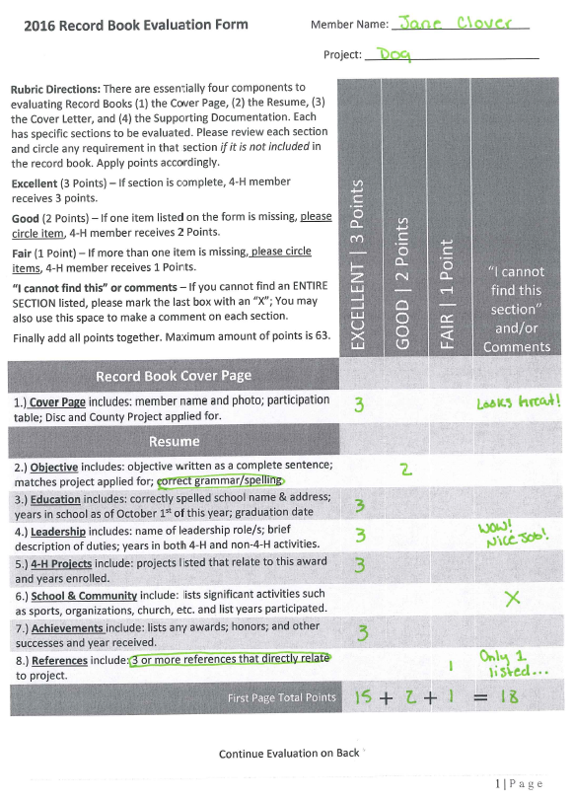

SAMPLE EVAULATION FORM

