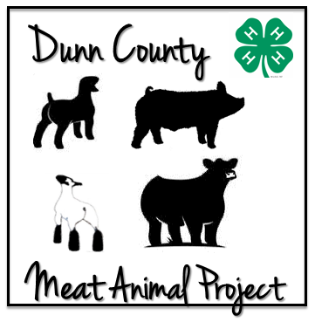
Dunn County 4-H/FFA Meat Animal Project
Educational Requirement Report (2019)

This sheet must be completed and turned into the Extension Office by 4:30pm on June 21, 2019

Please make an effort to answer questions completely to avoid this document being returned as ineligible.
Name and Club:

Species (check one) |  | Beef |  | Sheep |  | Swine |  | Meat Goat | Committee Approval:
What was the name of the educational workshop you attended?

Date held? / Where was it held?

Please list three things you learned at this educational event:

Why are each of these things important for you to know?

How are you going to use what you learned in your Meat Animal Project? (If you’re not, you should find another educational event!)

___________________________________ _________________________________
Project Member Signature Parent's Member Signature

Educational Requirements: To complete the educational requirements for 2019, you must attend a Rules Meeting, take and complete and turn in your certificate for YQCA, and then complete one other educational event. If there is no official sign in for your educational event, be sure to fill out this form, make a copy for your files, and turn in the original to the Extension Office.

Make sure to approve educational points if you’re questioning them.
The Meat Animal Committee reserves the right to deny unacceptable educational points.

  - Forms must be submitted to the Extension Office no later than 4:30 pm on June, 21, 2019.
  - This will include educational programs attended or presented.
  - Members failing to submit Educational Requirements prior to June 21, 2019 will not be allowed to sell their animals at the sale.
  - It is your responsibility to understand the MAP rules. Please be sure you have read and understood them before turning in any educational points forms.
  - Please check the Dunn County UW Extension Website under MAP (4-H Resources page) for approved educational opportunities.

Return to: Dunn County UW-Extension Office
4-H/FFA Meat Animal Project
3001 US Hwy 12 E, Suite 102
Menomonie, WI 54751
An AA/EEO employer, University of Wisconsin-Extension provides equal opportunities in employment and programming, including Title VI, Title IX and ADA requirements.

La Universidad de Wisconsin-Extensión, un empleador con igualdad de oportunidades y acción afirmativa (EEO/AA), proporciona igualdad de oportunidades en empleo y programas, incluyendo los requisitos del Titulo VI, Título IX, y de la Ley para Americanos con Discapacidades (ADA).

Tus Tswv Hauj Lwm Ntawm (EEO/AA), ntawm lub Tsev Kawm Ntawv Qib Siab (University of Wisconsin-Extension) pab rau kev ncaj ncees txog kev hauj lwm thiab kev pab cuam, xws li nyob rau hauv Title VI, Title IX, thiab ntawm tsab cai Americans with Disabilities Act (ADA) yuav tsum kom muaj.

